Project Initialization and Planning Phase

Date | 16 February 2026
Team ID | LTVIP2026TMIDS88973
Project Name | Civil-Engineering-Insight-Studio
Maximum Marks | 2 Marks

Customer Problem Statement: Civil Engineering Insight Studio:
Civil engineers and infrastructure professionals often face challenges managing project data, analysing site conditions, and making informed decisions efficiently. They must rely on multiple disconnected tools, manual calculations, and scattered reports to evaluate designs, monitor progress, and identify risks. This process is time-consuming, complex, and increases the chances of errors, delays, and inefficient resource utilization.
Many professionals struggle to gain clear insights from large volumes of technical data, making it difficult to optimize designs, predict potential issues, and ensure project quality and safety. This leads to uncertainty, reduced productivity, and difficulty delivering projects on time and within budget. 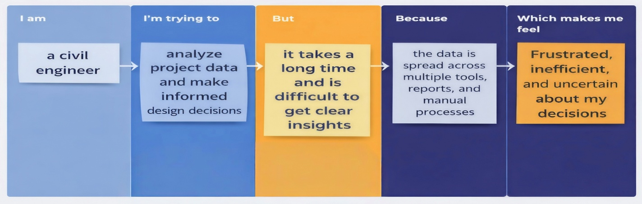
Problem Statement (PS) | I am (Customer) | I’m trying to | But | Because | Which makes me feel
PS-1 | a civil engineer | analyse project data and make informed design decisions | it takes a long time and is difficult to get clear insights | the data is spread across multiple tools, reports, and manual processes | Frustrated, inefficient, and uncertain about my decisions

